Sample of PhysicalVerification Pictures.

The table below illustrates some physical status of the verified assets with photographic evidence.
Table XXX: Physical verification photos
AGANGA HC III MATERNITY | 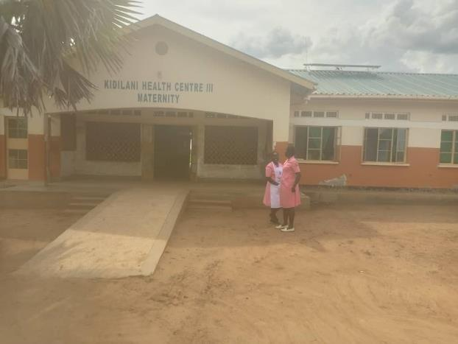
AGANGA HC MATERNITY AND WATER TANK | 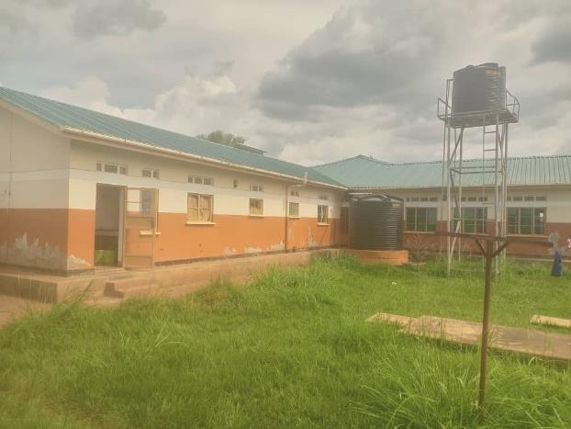
2 UNIT  STAFF QUARTERS | 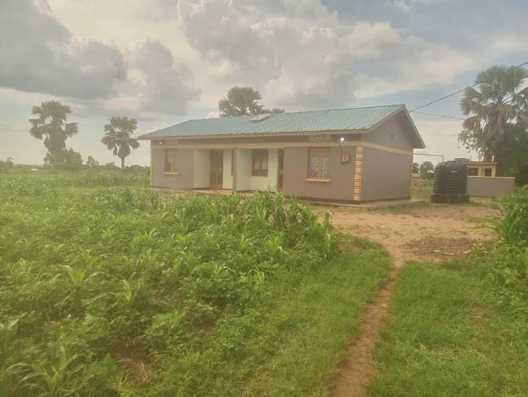
TOILETS | 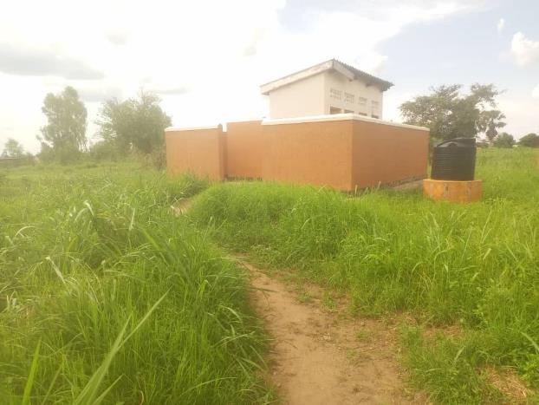
REFRIDGERATOR, BASIC | 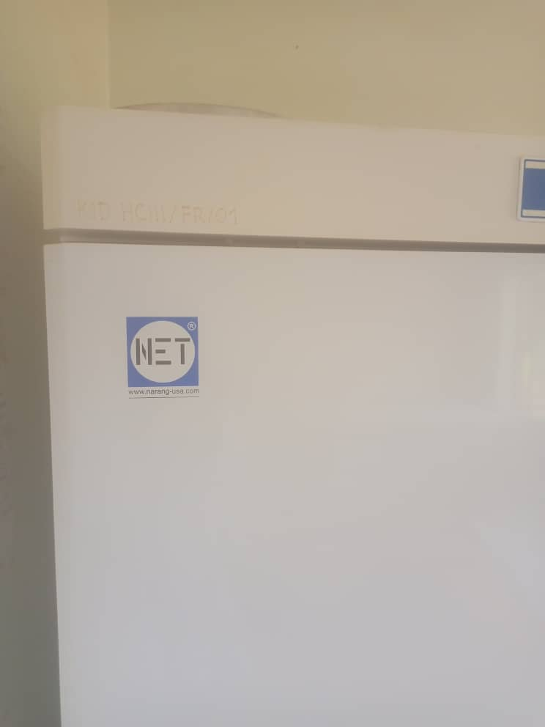
CUPBOARD STEEL, LOCKABLE | 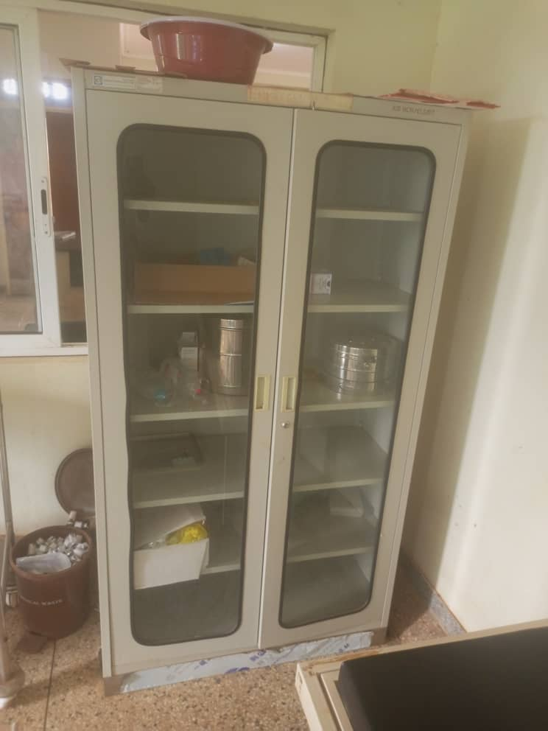
BENCH | 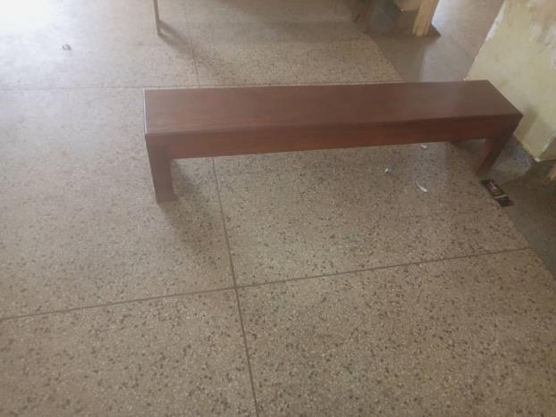
PLACENTA PIT | 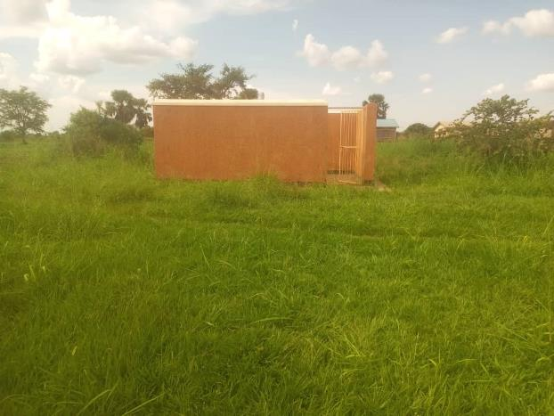
DELIVERY BED | 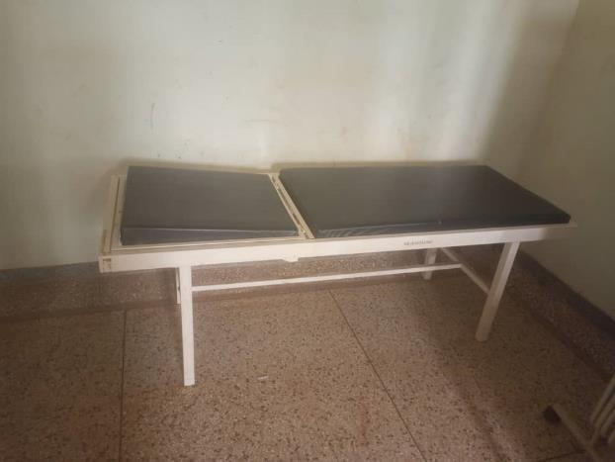
BED ADULT PATIENT ITH MATTRESS | 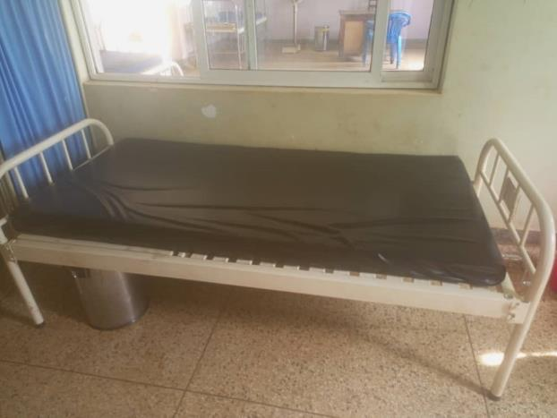
DRIP STAND, | 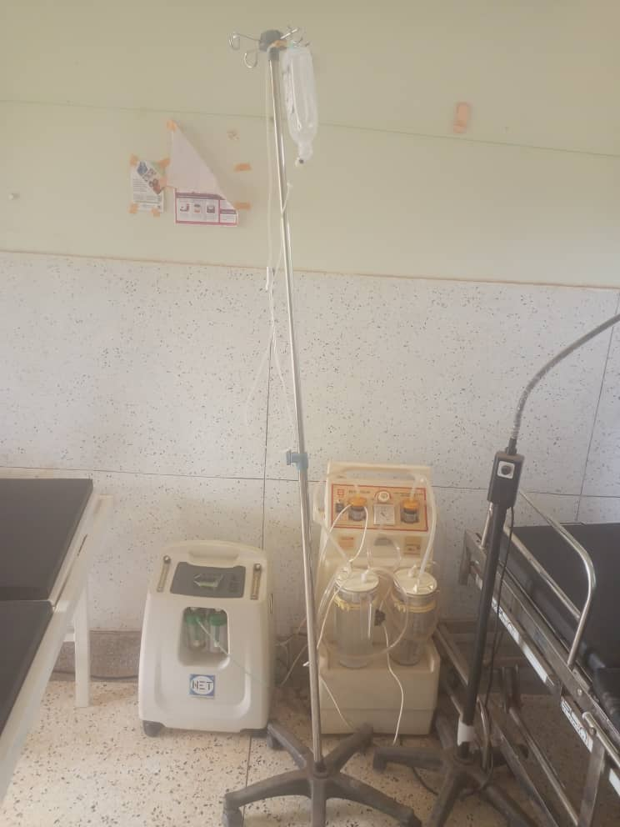
SUCTION APPARATUS | 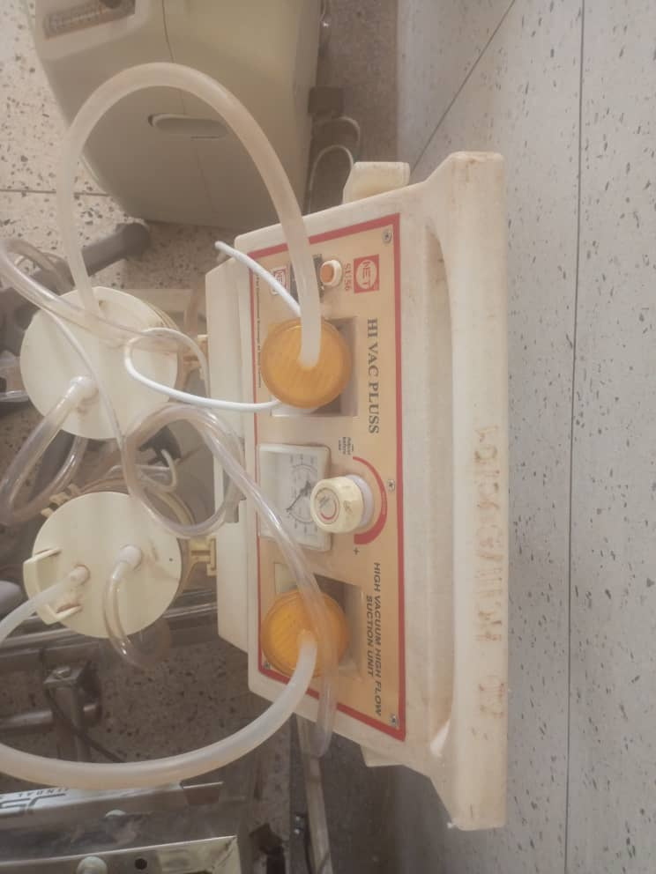
OXYGEN CONCENTRATOR | 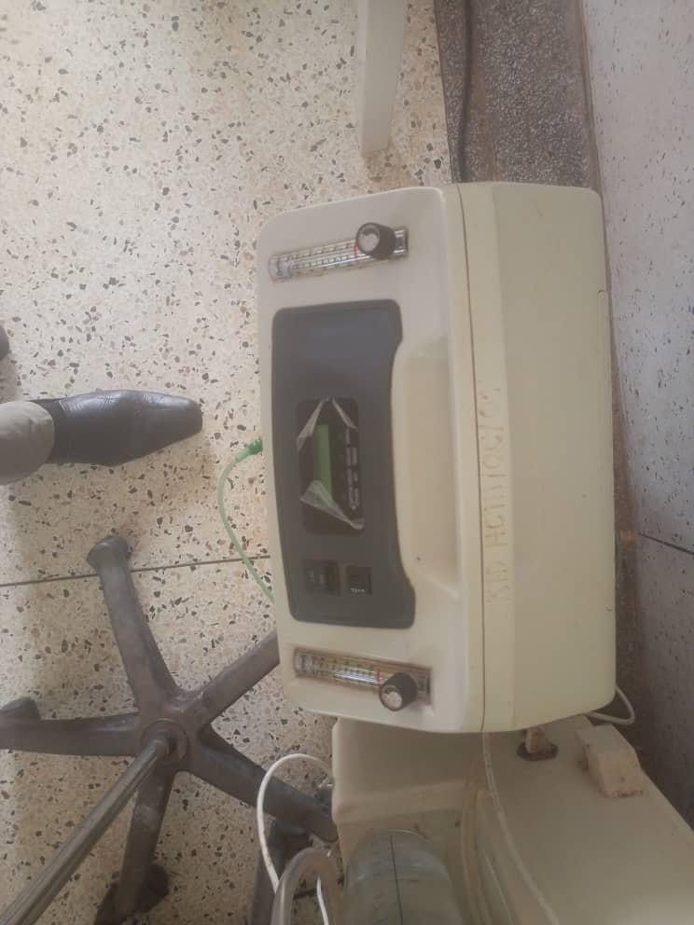
CUPBORARD STEEL, LOCKABLE ENGRAVEMENT | 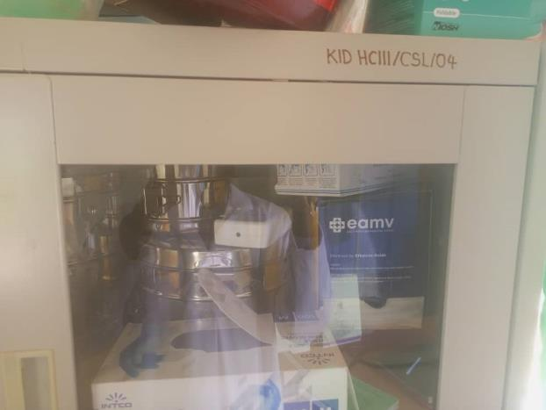
PATIENT TROLLEY AND INFECTION BUCKETS | 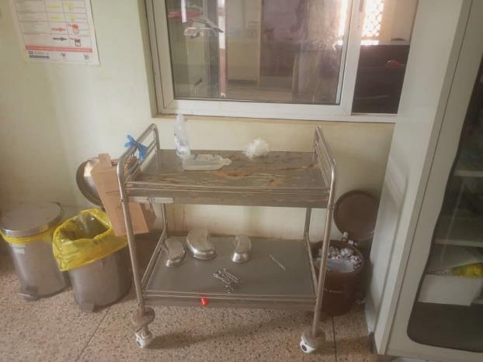
OXYGEN CONCENTRATOR ENVGRAVEMENT | 